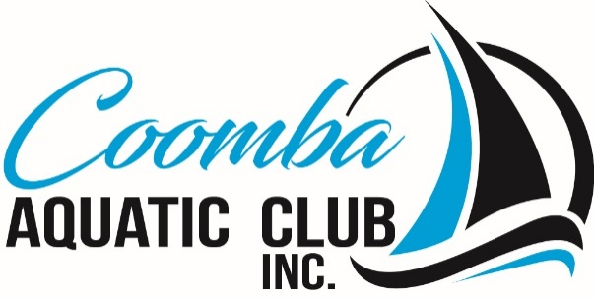

**Coomba Aquatic Club Incorporated**

**Committee Meeting**

**Points Discussed**

**Date/Time:** Monday 11th September 2023 at 10-11 am.

**Venue:** Coomba Aquatic Club

**1/ PRESENT**

President, Treasurer, Vice President, 5 Committee Members

**2/ APOLOGIES**

1 Committee Member

**3/ CONFIRMATION OF MINUTES OF MEETINGS**

The Minutes of the Committee Meeting held on 24th August 2023 taken as read and confirmed. Action Points register be available and confirmed by the Committee at each meeting.

**4/ DISCLOSURE OF ANY CONFLICTS OF INTEREST IN ANY AGENDA ITEM**

Nil disclosed.

**5/ CORRESPONDENCE**

**In.** Wallis Lake Fishing Club Business Name Renewal Notice. Mid Coast Assist Christmas in July Luncheon thank you letter. St George Bank account statement. Annual ATO GST Form.

**Out.** Nil.

**6/ TREASURER’S REPORT**

1. Financial Report presented for August and the Mid Coast Council Grant Application reconciliation.
2. Treasurer advised the Regional Bank Community Partnership Program Application Form had been submitted to the bank.

**7/ WEBSITE & FACEBOOK**

1. The clubs new website is up and running with some basic information provided, bistro menus and upcoming listed, more information to be added as its received or developed.

**8/ SUMMER SAILING PROGRAM**

1. Flyers with the full season’s sailing program had been distributed around Coomba village.
2. Applications for the 2023/24 Sailing Scholarship have been received from Bethany Cannon and Ella Cannon. Selection committee will meet with Bethany & Ella and their parents Monday 11th September.
3. The first Sailability Day will be Tuesday 26th September from 10-00 am. The

Club’s Safety Boat will be picked up from Chris Hutchison’s jetty. A reminder e-mail be sent to the Committee and volunteers.

**9/ MEMBERSHIP MATTERS**

1. Membership Cards printed and being distributed to Members.

**10/ CLUBHOUSE MATTERS**

1. The President has obtained agreement from Brian Cotterill and Steve Martin to form a Sub-Committee to undertake the Building Extension Program, reporting to the Committee. Chris Hutchison and Peter Brown will be contacted to ascertain their interest.
2. A sample clean of a section of the Clubhouse floor with the cleaning materials will be carried out by committee members to determine what further action is required to clean the entire floor.
3. Committee to investigate options for 120 new wine glasses to be used for larger events only.
4. Vicki Johnston (Chef) will be away on the 27/12, 30/12 & 3/1.Committee to assess a proposal for *R&R Cruzin Cuisine* *Mexican* food van to cover the above dates. If approved the van is to be located in the carpark adjacent to the disabled parking.
5. Committee members to investigate options for three (3) outdoor umbrellas and three (3) outdoor tables (6-seater) to be located on the end balcony of the Clubhouse during warmer months costs and details to be provided at next meeting.
6. A Mini Sewage Treatment Plant will need to be installed to replace the current system at the Club’s cost by the end of 2024. Estimated costs in the vicinity of $30k including freight and installation. The Club will need to chase grants for this expenditure. Grant applications to be developed.

**11/ EVENTS & BOOKINGS**

1. The Christmas BBQ will be on Friday 22/12 – Further information to be provided.
2. A Sub-Committee of 3 committee members will head up the arrangements for Coombafest.
3. Mid Coast Council to be contacted about outdated information on their Website in relation to bookings for the Clubhouse & Gazebo
4. Upcoming WLFC events - 7th OctoberGone Fishing Day at CAC, 8th October All Things Fishing at Reflections Caravan Park, Forster.
5. The first BYO *Sunday Sips* event was confirmed for Sunday 3rd December from 2-00 pm. The Committee will provide light snacks at a cost to be confirmed.

**12/ OTHER BUSINESS**

1. Work in progress with Warwick Tillman in relation to the generator overheating and the installation of an external exhaust pipe to rectify the issue.
2. The Building of H4 timber stairs near the grease trap was approved.
3. A Stand-Up Bar on the northeastern side of the Gazebo proposal submitted. The Committee gave approval to proceed.
4. The *Coomba Gardening & Produce* Legal Liability Insurance Certificate was tabled. This will allow their get togethers to continue in the Gazebo on the second Saturday of each month.

**12/ NEXT MEETING**

The next meeting was confirmed for 10-00 am. Monday 9th October 2023.

**13/ CLOSURE**

The meeting closed at 1-00 pm.