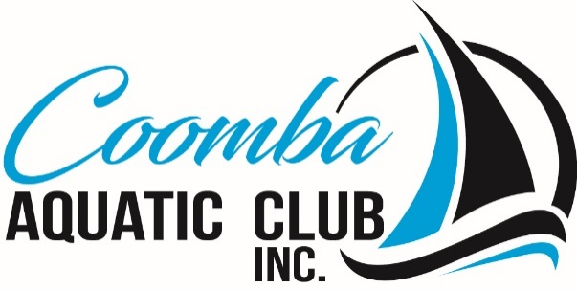

**Coomba Aquatic Club**

**October General Meeting**

**Points Discussed**

**Date/Time:** 9th October 2023 at 10.00 am.

**Venue:** Coomba Aquatic Club

1. **PRESENT**

President, Treasurer and Three Committee Members

1. **APOLOGIES**

Three Committee Members

1. **CONFLICT OF INTEREST**

Two members also on Fishing Club committee.

1. **MINUTES OF SEPTEMBER MEETING**

Minutes of CAC September Meeting Approval – by two Committee Members

1. **TREASURER’S REPORT**

Approval – by two Committee Members

1. **JUNIOR SAILING**

Record numbers of children attended the Tuesday Junior sailing sessions, The club safety boat employed to entertain them while the waited for their turn on the Bic’s. Promoting the Junior Sailing at Pacific Palms Primary School had a good roll up of local children.

1. **FISHING CLUB**

A meeting will be arranged with the fishing club to discuss on going issues, as well as provide a response to email sent to CAC. Meeting set for Sunday 29th October at 11.00am 2023.

1. **GENERAL BUSINESS**

Date for the next Aquatic Club Ball, discussed changing the ball bringing it forward to June in 2024.

New storage cupboards and moving the fire extinguisher located in the Main Club House Southern Lefthand Corner to the pillar by the western fire door.

Plaque replacement, Spelling wrong on a members plaque arrangements in place to replace plaque with correct names.

Look into CAC acquiring Crown Lease for the site.

Speakers Outside continue to push council for a response.

Solar Lights and Bollards – Works scheduled for 13 November2023.

**NEXT MEETING**

Coomba Aquatic Club, 10.00am 9th November 2023

President